RD274

In this tutorial, I'll show you an extremely simple way to secure your phone with a Flash Menu or make any Flash Menu password protected.
First of all we'll need 2 programs -
Adobe Flash CS3/CS4
SWF Decompiler
The SWF Decompiler will decompile the menu for us, while Flash CS3 is where we will be doing all the real work. Any number written in brackets correspond to the number in the image.
For the sake of this tutorial, I will be password-protecting the Flash Menu "Connecto" which comes with the W595.
----------------------------------------------
STEP 1-
Using SWF Decompiler decompile the "Connecto_Desktop.swf" file and open it in Flash CS3.
Make any necessary changes to the Flash Menu (like the icons or whatever you wish to do). Then proceed to Step 2.
----------------------------------------------
STEP 2-
Now look at the top, on the layers panel .... Select all the layers (1) and drag them to Frame 3 (2).
----------------------------------------------
STEP 3-
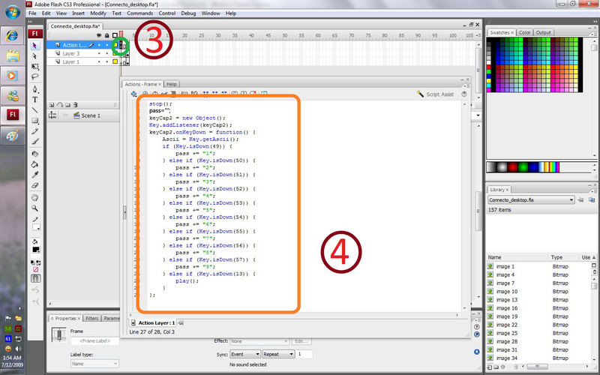
-Click on the First Frame on Actionscript Layer (3).
-Now Press "F9" to bring down the Actionscript Toolbox. Now Copy-Paste the Following Script into the ActionScript Toolbox(4).

stop();
pass="";
keyCap2 = new Object();
Key.addListener(keyCap2);
keyCap2.onkeydown = function() {
Ascii = Key.getAscii();
if (Key.isDown(49)) {
pass += "1";
} else if (Key.isDown(50)) {
pass += "2";
} else if (Key.isDown(51)) {
pass += "3";
} else if (Key.isDown(52)) {
pass += "4";
} else if (Key.isDown(53)) {
pass += "5";
} else if (Key.isDown(54)) {
pass += "6";
} else if (Key.isDown(55)) {
pass += "7";
} else if (Key.isDown(56)) {
pass += "8";
} else if (Key.isDown(57)) {
pass += "9";
} else if (Key.isDown(13)) {
play();
}
};
----------------------------------------------
STEP 4-
-Now right-click on Frame 2 on ActionScript Layer and click "Convert to KeyFrame" (5).
-With Frame 2 highlighted (6), Copy-Paste the Following Script into the ActionScript Toolbox (7).
-Remember to Replace "xxxx" in the code with your preffered password.
Key.removeListener(keyCap2);
if (pass=="xxxx")
{
gotoAndStop(3);
}
else
{
pass="";
gotoAndPlay(1);
}
Your Menu is now password enabled.
----------------------------------------------
STEP 5-
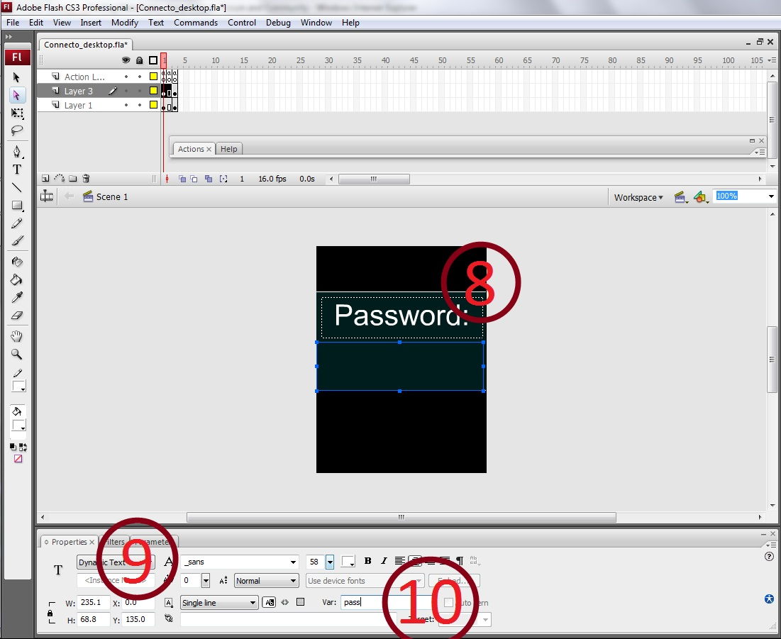
Now Create Some Visual Elements (if you wish to) for your menu (Like what I made in the Image below).
- Make a Box in the lowermost layer (Layer 1 as reference) like I made a dark green one.
- In the Middle layer (Layer 3 as reference)->
+Make the "Password" text box (8).
+Make the other text box blank but with type as 'dynamic' (9) and put the variable as "pass" (10).
-Now click File>Export>"Export As..." and export it as per you're requirements.
Enjoy !
Remember to Test the Menu on your phone once before actually implementing it!

